Automation Exercise - APIs

TCID_API 1: Get All Products List.
- API URL: https://automationexercise.com/api/productsList
- Request Method: GET
- Response Code: 200
- Response JSON: All products list
Script:
pm.test("Status code is 200", function () {
pm.response.to.have.status(200);
});
pm.test("Response has valid JSON", function () {
pm.expect(pm.response.json()).to.be.an("object");
});
pm.test("Products list exists", function () {
const jsonData = pm.response.json();
pm.expect(jsonData).to.have.property("products");
pm.expect(jsonData.products.length).to.be.above(0);
});
Test Result:
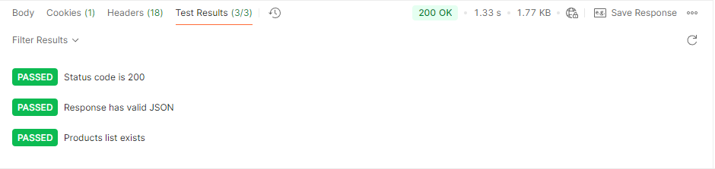

TCID_API 2: POST To All Products List
- API URL: https://automationexercise.com/api/productsList
- Request Method: POST
- Response Code: 405
- Response Message: This request method is not supported.
Script:
pm.test("Status code is 405", function () {
pm.response.to.have.status(405);
});
pm.test("Response has valid JSON", function () {
pm.expect(pm.response.json()).to.be.an("object");
});
pm.test("Response message is correct", function () {
const jsonData = pm.response.json();
pm.expect(jsonData).to.have.property("message", "This request method is not supported.");
});
Test Result:
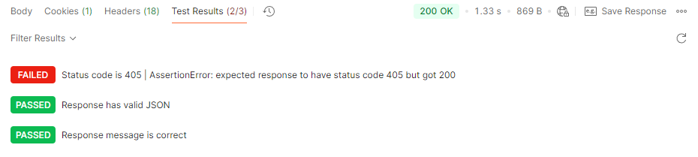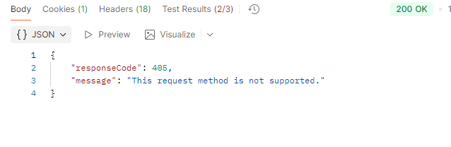

TCID_API 3: Get All Brands List.
- Request Method: GET
- Response Code: 200
- Response JSON: All brands list
SCRIPT:
// Test 1: Verify status code is 200 OK
pm.test("Status code is 200 OK", function () {
pm.response.to.have.status(200);
});
// Test 2: Verify that the response contains valid JSON
pm.test("Response is valid JSON", function () {
pm.response.to.be.json;
});
// Test 3: Verify that the JSON response contains a brands property that is an array
pm.test("Response contains brands array", function () {
var jsonData = pm.response.json();
pm.expect(jsonData).to.have.property('brands');
pm.expect(jsonData.brands).to.be.an('array');
});
Test Result:
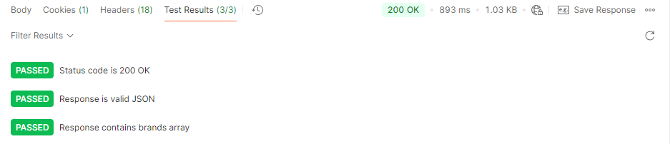

TCID_API 4: PUT To All Brands List
- Request Method: PUT
- Response Code: 405
- Response Message: This request method is not supported.
SCRIPT:
// Test 1: Verify status code is 405 (Method Not Allowed)
pm.test("Status code is 405 Method Not Allowed", function () {
pm.response.to.have.status(405);
});
// Test 2: Verify that the response contains valid JSON
pm.test("Response is valid JSON", function () {
pm.response.to.be.json;
});
// Test 3: Verify that the response message says "This request method is not supported."
pm.test("Response message indicates method not supported", function () {
var jsonData = pm.response.json();
pm.expect(jsonData.message).to.eql("This request method is not supported.");
});
Test Result:
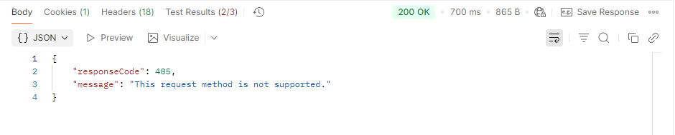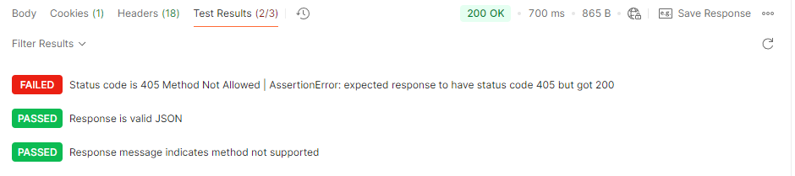

TCID_API 5: POST To Search Product
- Request Method: POST
- Request Parameter: search_product (For example: top, tshirt, jean)
- Response Code: 200
- Response JSON: Searched products list
- Body: form-data
Key: Search_product Value: Top

SCRIPT:
// Test 1: Verify that the request method is POST
pm.test("Request method is POST", function () {
pm.expect(pm.request.method).to.equal("POST");
});

// Test 2: Verify that the request has the search_product parameter in the body
pm.test("Request body contains search_product parameter", function () {
const requestBody = pm.request.body;

// Check if body mode is formdata
if (requestBody && requestBody.mode === 'formdata') {
const formData = requestBody.formdata;
const searchProductParam = formData.find(param => param.key === 'search_product');
pm.expect(searchProductParam).to.not.be.undefined;
pm.expect(searchProductParam.key).to.equal('search_product');
} else {
pm.expect.fail("Request body is not in formdata mode");
}
});
// Test 3: Verify that the status code is 200
pm.test("Status code is 200", function () {
pm.response.to.have.status(200);
});
// Test 4: Verify that the response contains valid JSON
pm.test("Response is valid JSON", function () {
pm.response.to.be.json;
pm.expect(function() {
pm.response.json();
}).to.not.throw();
});
// Test 5: Verify that the response contains a products property that is an array
pm.test("Response contains products array", function () {
const jsonData = pm.response.json();
pm.expect(jsonData).to.have.property('products');
pm.expect(jsonData.products).to.be.an('array');
});
Test Result:
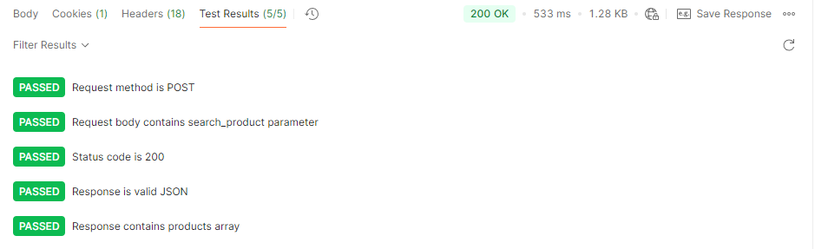

TCID_API 6: POST To Search Product without search_product parameter
- Request Method: POST
- Response Code: 400
- Response Message: “Bad request, search_product parameter is missing in POST request.”.
Script:
// Test 1: Verify that the request method is POST
pm.test("Request method is POST", function () {
pm.expect(pm.request.method).to.equal("POST");
});

// Test 2: Verify that the status code is 400 (Bad Request)
pm.test("Status code is 400 (Bad Request)", function () {
pm.response.to.have.status(400);
});

// Test 3: Verify that the response contains valid JSON
pm.test("Response is valid JSON", function () {
pm.response.to.be.json;
});

// Test 4: Verify that the response message is correct
pm.test("Response message indicates missing search_product parameter", function () {
var jsonData = pm.response.json();
pm.expect(jsonData.message).to.equal("Bad request, search_product parameter is missing in POST request.");
});
Test Result:
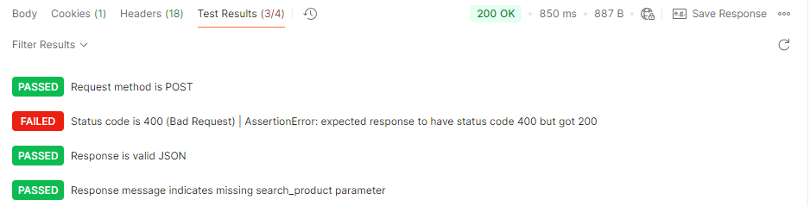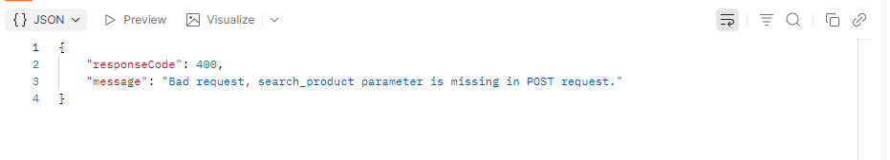

TCID_API 7: POST To Verify Login with valid credentials
- Request Method: POST
- Request Parameter: email & password
- Response Code: 200
- Response Message: User Exists

Script :
// 1. Assert that the response status code is 200
pm.test("Status code is 200", function () {
pm.response.to.have.status(200);
});
// 2. Assert that the response body contains a 'responseCode' property
pm.test("Response has 'responseCode' property", function () {
var jsonData = pm.response.json();
pm.expect(jsonData).to.have.property('responseCode');
});
// 3. Assert that 'responseCode' is 200 for success or 400 for bad request
pm.test("'responseCode' is 200 (success) or 400 (bad request)", function () {
var jsonData = pm.response.json();
pm.expect([200, 400]).to.include(jsonData.responseCode);
});
// 4. Optionally, check for a 'message' property in the response
pm.test("Response optionally has 'message' property", function () {
var jsonData = pm.response.json();
pm.expect(jsonData).to.have.any.keys('message');
});
Test Result:
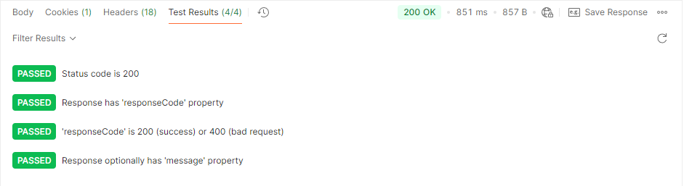

TCID_API 8: POST To Verify Login without email parameter
- Request Method: POST
- Request Parameter: password
- Response Code: 400
- Response Message: Bad request, email or password parameter is missing in POST request.

Script:
// 1. Validate request method is POST
pm.test("Request method is POST", function () {
pm.expect(pm.request.method).to.eql("POST");
});

// 2. Validate 'password' parameter is present in request body (form-data)
pm.test("Request body contains 'password' parameter", function () {
var formData = pm.request.body && pm.request.body.formdata ? pm.request.body.formdata.all() : [];
var hasPassword = formData.some(function(param) {
return param.key === "Password" && param.value;
});
pm.expect(hasPassword, "'Password' parameter should be present in form-data").to.be.true;
});

// 3. Validate response code is 400
pm.test("Response code is 400", function () {
pm.response.to.have.status(400);
});

// 4. Validate response message
pm.test("Response message is correct", function () {
var resText = pm.response.text();
pm.expect(resText).to.include("Bad request, email or password parameter is missing in POST request.");
});
Test Result:
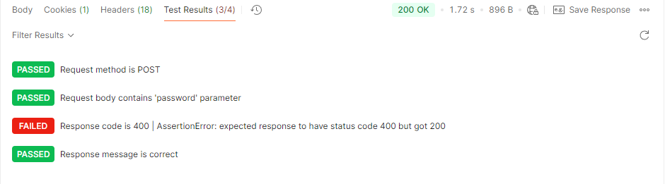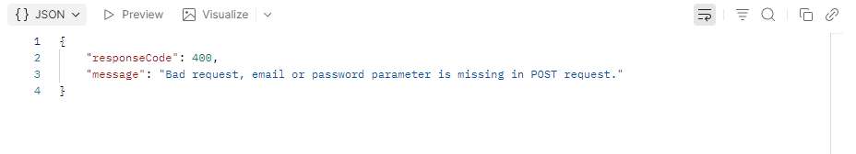

TCID_API 9: DELETE To Verify Login
- Request Method: DELETE
- Response Code: 405
- Response Message: This request method is not supported.

Script:
// 1. Validate the request method is DELETE
pm.test("Request method is DELETE", function () {
pm.expect(pm.request.method).to.eql("DELETE");
});

// 2. Validate the response code is 405
pm.test("Response code is 405", function () {
pm.response.to.have.status(405);
});

// 3. Validate the response message is 'This request method is not supported.'
pm.test("Response message is 'This request method is not supported.'", function () {
var responseText = pm.response.text();
pm.expect(responseText).to.include("This request method is not supported.");
});
Test Result:
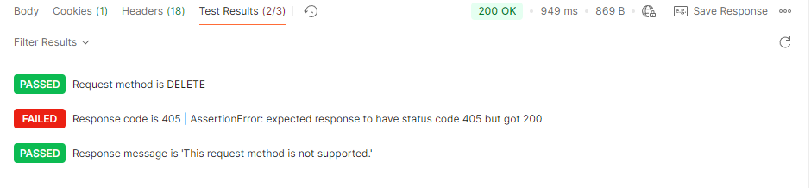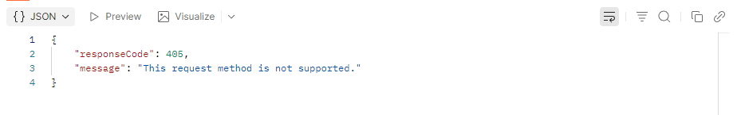

TCID_API 10: POST To Verify Login with invalid details
- Request Method: POST
- Request Parameter: email & password
- Response Code: 400
- Response Message: Bad request, email or password parameter is missing in POST request.

Script:
// Validate Status Code
pm.test("Status code is 404", function () {
pm.response.to.have.status(404);
});

// Validate response is valid JSON
pm.test("Response has valid JSON", function () {
pm.response.to.be.json;
});

// Validate response message
pm.test("Response message is correct", function () {
var jsonData = pm.response.json();
pm.expect(jsonData.message).to.eql("User not found!");
});
Test Result:
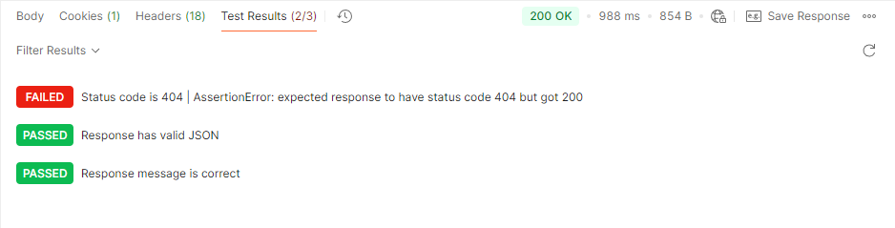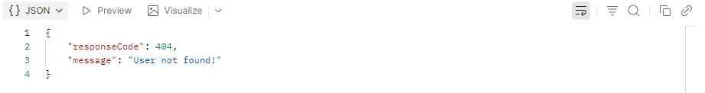

TCID_API 11: POST To Create/Register User Account
- API URL: https://automationexercise.com/api/createAccount
- Request Method: POST
- Request Parameters: name, email, password, title (for example: Mr, Mrs, Miss), birth_date, birth_month, birth_year, firstname, lastname, company, address1, address2, country, zipcode, state, city, mobile_number
- Response Code: 201
- Response Message: User created!

Script:
pm.test("Status code is 201", function () {
pm.response.to.have.status(201);
});
pm.test("Response has valid JSON", function () {
pm.expect(pm.response.json()).to.be.an("object");
});
pm.test("Response message is correct", function () {
const jsonData = pm.response.json();
pm.expect(jsonData).to.have.property("message", "User created!");
});
Test Result:
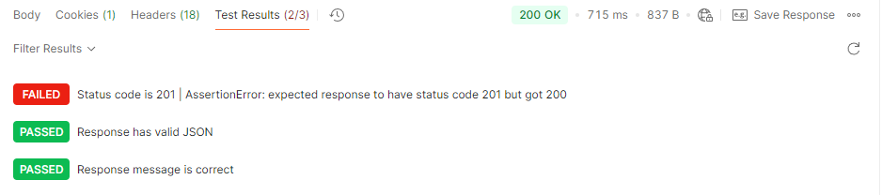

TCID_API 12: DELETE METHOD To Delete User Account.

- API URL: https://automationexercise.com/api/deleteAccount
- Request Method: DELETE
- Request Parameters: email, password
- Response Code: 200
- Response Message: Account deleted!
Script:
// Basic response validation
pm.test("Status code is 200", function () {
pm.response.to.have.status(200);
});
// Validate response JSON shape and values
pm.test("Response has expected fields and values", function () {
const json = pm.response.json();
pm.expect(json).to.have.property("responseCode", 200);
pm.expect(json).to.have.property("message", "Account deleted!");
});
// Optional: verify request body contains required params before send
pm.test("Request contains email and password params", function () {
const body = pm.request.body ? pm.request.body.urlencoded : [];
const asMap = body.reduce((acc, kv) => (acc[kv.key] = kv.value, acc), {});
pm.expect(asMap).to.have.property("email").and.to.be.a("string").and.not.empty;
pm.expect(asMap).to.have.property("password").and.to.be.a("string").and.not.empty;
});
Test Result:
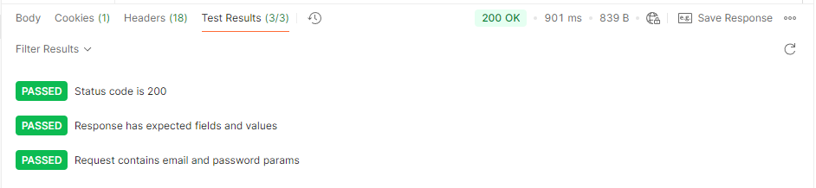

TCID_API 13: PUT METHOD To Update User Account.
- API URL: https://automationexercise.com/api/updateAccount
- Request Method: PUT
- Request Parameters: name, email, password, title (for example: Mr, Mrs, Miss), birth_date, birth_month, birth_year, firstname, lastname, company, address1, address2, country, zipcode, state, city, mobile_number
- Response Code: 200
- Response Message: User updated!
Script:
// Validate Status Code
pm.test("Status code is 200", function () {
pm.response.to.have.status(200);
});

// Validate response is valid JSON
pm.test("Response has valid JSON", function () {
pm.response.to.be.json;
});

// Validate success message
pm.test("Response message is correct", function () {
const jsonData = pm.response.json();
pm.expect(jsonData.message).to.eql("User updated!");
});

Test Result:
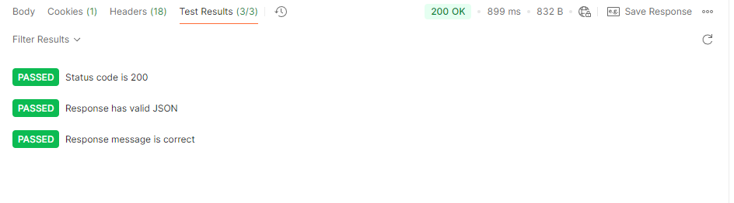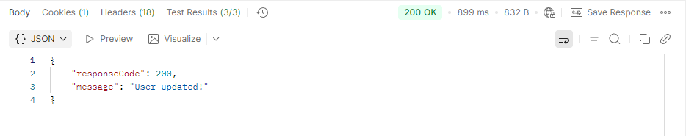

API 14: GET user account details by email
- API URL: https://automationexercise.com/api/getUserDetailByEmail
- Request Method: GET
- Request Parameters: email
- Response Code: 200
- Response JSON: User Detail

Script:
// Validate request method
pm.test("Request method is GET", function () {
pm.expect(pm.request.method).to.eql("GET");
});
// Validate required query param `email`
pm.test("Email query param is present", function () {
const emailParam = pm.request.url.query.get("email");
pm.expect(emailParam, "email query param should be present").to.be.a("string").and.not.be.empty;
});
// Validate response status
pm.test("Response status is 200", function () {
pm.response.to.have.status(200);
});
// Try to parse JSON and validate "User Detail"-like structure
pm.test("Response body is JSON with user detail", function () {
let json;
try {
json = pm.response.json();
} catch (e) {
pm.expect.fail("Response is not valid JSON");
}
// Basic checks — adjust keys as your API guarantees
pm.expect(json, "Response should be an object").to.be.an("object");
// Common shapes seen for user detail APIs
// Accept either a top-level user object or a wrapped payload
const user =
json.user ||
json.data ||
(Array.isArray(json) ? json[0] : json);
pm.expect(user, "User detail object should exist").to.be.an("object");
// Lenient field assertions — adapt to your API schema if known
const possibleFields = ["id", "name", "email", "username", "first_name", "last_name"];
const hasAnyExpectedField = possibleFields.some((k) => Object.prototype.hasOwnProperty.call(user, k));
pm.expect(hasAnyExpectedField, "User object should contain common user fields").to.be.true;
// If email was requested, ensure it matches when present
const requestedEmail = pm.request.url.query.get("email");
if (user.email) {
pm.expect(String(user.email).toLowerCase()).to.eql(String(requestedEmail).toLowerCase());
}
});
Test Result:
